**TRELLO APP**

The webpage make by using React JS and Redux to maintained the state variable. The First page is contain at the top ADD CARD button to add the card on any column.

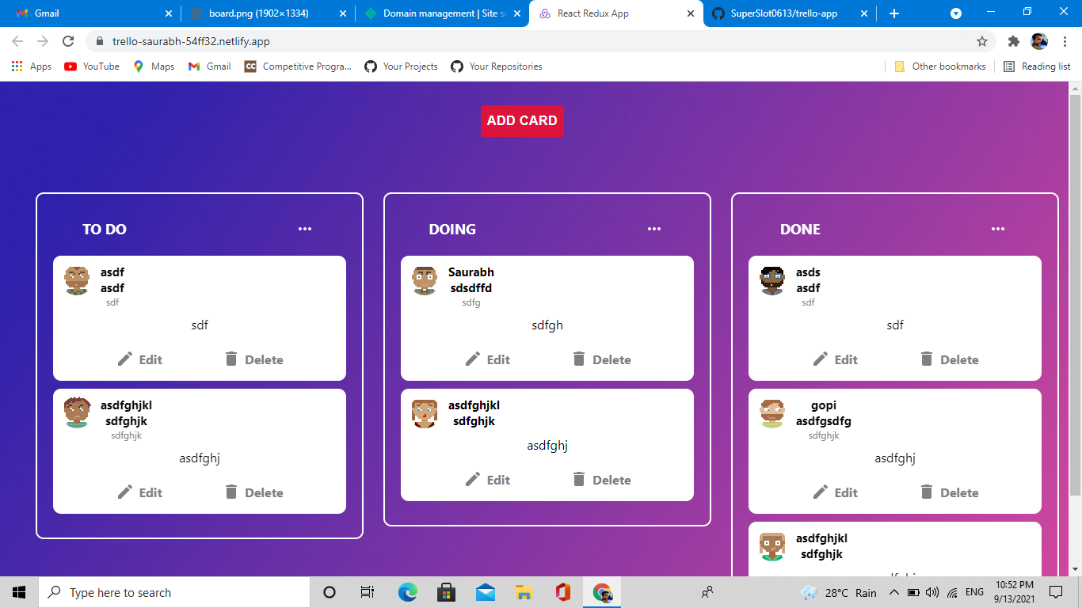

After clicking on ADD CARD Button the card form is open were user enter there all recommended input text.

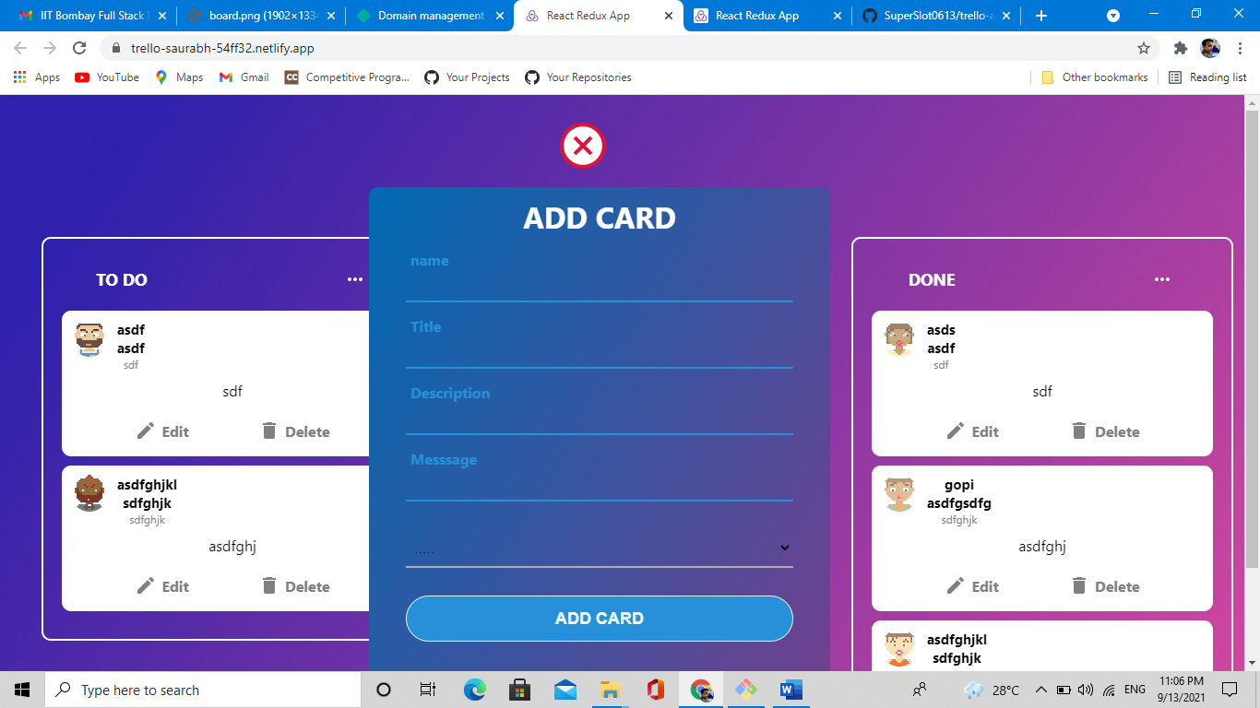

After submit the add card form the card is reflect on that column.

At every card there is two button one is edit and other is delete button.

After clicking on edit button the edit form is open were user can edit there card details.

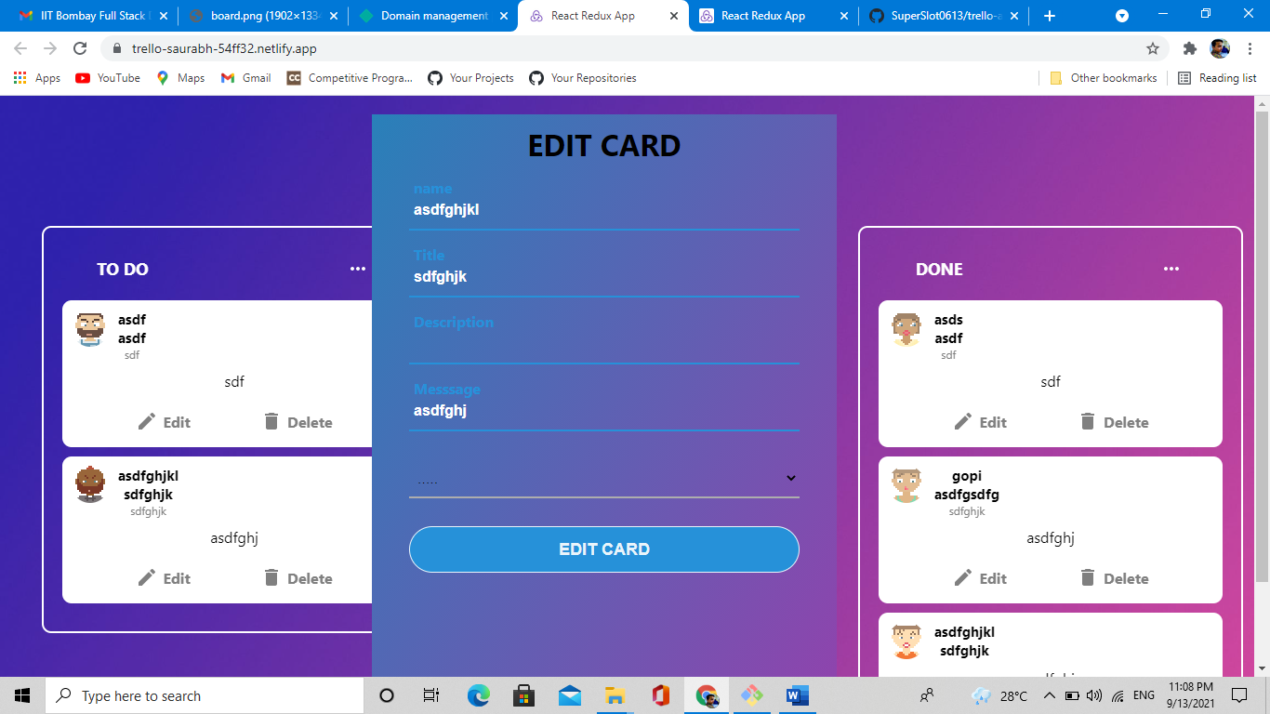

In every card there is a avatar icon which generated by randomly.